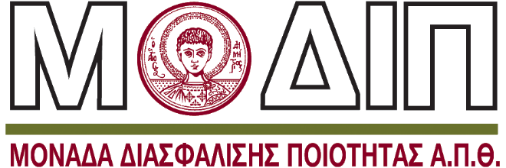

Επισπεύδον Τμήμα
Γεωπονίας

Διατμηματικό Ξενόγλωσσο
Προπτυχιακό Πρόγραμμα Σπουδών

ιη.
Ενημερωτικό υλικό προς φοιτητές του ΞΠΠΣ
(στα ελληνικά και αγγλικά)

Ιανουάριος / 2026

Dear Students,

It is my great pleasure to welcome you to the Interdepartmental English-Taught Undergraduate Programme “Sustainable Agriculture and Food Science,” a five-year full-time programme leading to a fully accredited Integrated Master’s Degree (300 ECTS, Level 7 of the European Qualifications Framework), jointly offered by the School of Agriculture and the School of Chemistry of the Aristotle University of Thessaloniki.
Τhis integrated structure enables you to complete both undergraduate and master-level studies within a single academic pathway, providing advanced scientific training, professional specialization, and a direct route to doctoral studies and high-level careers in the global agri-food sector.
By joining this programme, you become part of one of the oldest and most distinguished academic communities in Agricultural and Chemical Sciences in Southeastern Europe. The School of Agriculture of the Aristotle University of Thessaloniki, established in 1927, has played a central role in the development of agricultural science, food production, environmental protection, and rural development in Greece and beyond. Complementing this long-standing tradition, the School of Chemistry contributes strong expertise in chemical sciences, and environmental analysis, further strengthening the programme’s interdisciplinary character. From its foundation, the School of Agriculture has embraced a comprehensive approach covering the entire agri-food chain — from primary production and natural resource management to food processing, quality, safety, and sustainability.
The Aristotle University of Thessaloniki is consistently ranked among the leading institutions in Europe in Agricultural and Food Sciences. According to EduRank, the University ranks #22 in Agriculture and #17 in Food Science in Europe, outperforming many prestigious institutions across the continent and standing as the leading institution in Greece and Southeastern Europe in these fields.
Your studies in this programme will equip you with advanced scientific knowledge, critical thinking skills, and practical competencies necessary to address major global challenges such as climate change, food security, biodiversity loss, sustainable resource management, and the transformation of agri-food systems. Graduates are prepared to become leaders, researchers, and innovators contributing to sustainable development at local, regional, and global scales.
The Aristotle University of Thessaloniki — the largest university in Greece and one of the leading academic institutions in Southeastern Europe — offers a vibrant multicultural environment supported by distinguished faculty members, modern laboratories, comprehensive libraries, advanced research facilities, and extensive student services. You will also benefit from career development support, language learning opportunities, sports facilities, innovation and technology transfer structures, and a dynamic student life in the city of Thessaloniki.
University life is not only a period of academic study but also a time of personal growth, intercultural exchange, responsibility, and discovery. We encourage you to fully engage in the academic community and to make the most of the opportunities provided throughout your studies.
I assure you that our faculty and staff are fully committed to supporting you throughout your academic journey. Our doors remain open to your questions, ideas, and aspirations.
I wish you every success in your studies and a rewarding experience at the Aristotle University of Thessaloniki.

Welcome to our academic community.

Thomas Kotsopoulos, Professor
Head of the Department of Agriculture
Aristotle University of Thessaloniki

School of Agriculture and School of Chemistry

The Interdepartmental Programme “Sustainable Agriculture and Food Science” is jointly supported by the School of Agriculture and the School of Chemistry of the Aristotle University of Thessaloniki.
The School of Agriculture, established in 1927, provides a comprehensive scientific framework covering all major domains of agricultural production, food systems, and environmental management. Its academic structure includes disciplines such as crop science, animal science, soil science, agricultural engineering, food science and technology, agricultural economics, plant protection, and sustainability.
A distinctive advantage of the School of Agriculture is its educational farm of approximately 180 hectares, located immediately adjacent to the metropolitan area of Thessaloniki. This unique facility functions as a living laboratory where students engage in field experiments, applied research, technological innovation, and hands-on training across all sectors of agricultural production and environmental management. The proximity of such a large, fully equipped agricultural facility to a major European city constitutes a rare asset internationally and a cornerstone of the educational experience we offer.
Research excellence is a defining feature of the School of Agriculture. Our faculty members participate in numerous competitive European research programmes — including Horizon Europe, PRIMA, and Erasmus+ — and collaborate with leading universities, research centres, and stakeholders worldwide. This strong international networking creates opportunities for students to engage with cutting-edge scientific developments and innovation ecosystems at the European level.
Over the years, the School has developed extensive infrastructure, including numerous specialized laboratories, research units, and modern facilities supporting education, innovation, and collaboration with industry and public institutions. The participation of the School of Chemistry further strengthens the programme’s scientific foundation, providing advanced expertise in chemical sciences, analytical techniques, food chemistry, biotechnology, and environmental chemistry. Together, the two Schools create a truly multidisciplinary environment aligned with contemporary scientific developments and societal needs.
The School of Chemistry contributes strong scientific expertise in the chemical sciences, including analytical chemistry, food chemistry, biotechnology, and environmental chemistry. Modern laboratories and advanced scientific instrumentation support both education and research, providing the necessary scientific foundation for understanding food composition, safety, processing, biotechnology, and environmental impacts.
Together, the two Schools create a multidisciplinary academic environment that integrates life sciences, chemical sciences, environmental studies, and technological innovation. This collaboration ensures that students acquire a comprehensive understanding of sustainable agriculture and food systems, from primary production to processing, quality, safety, and policy.

Aristotle University of Thessaloniki
The Aristotle University of Thessaloniki (AUTh) was founded in 1925 and was named after the famous ancient philosopher Aristotle. It is one of the largest University of Greece, covering an area of about 34 hectares and located in the city centre.
It consists of 41 Faculties and Schools offering all kinds of studies, has about 74.000 registered students (65.000 undergraduate and 9.000 postgraduate, 4.000 of which at Doctoral level), more than 2.500 permanent teaching staff and approximately 800 permanent administrative staff.
AUTh houses 16 Museums, Archives and Collections, has 3 choirs, 1 orchestra, 1 opera. It facilitates a Gym providing a wide range of sports’ programmes and activities, a restaurant where more than 15,000 meals are served to all members of the university community on a daily basis and a Career Services Oﬃce where you can get detailed information and advice about studies, career and employment opportunities. The university also has a Camp in Kalandra (Halkidiki), a piny area next to the sea.
AUTh takes part in the Erasmus exchange programme and is a member in 11 student unions.
Finally, AUTh was certified as fully compliant by the Hellenic Quality Assurance and Accreditation Agency Board on 10/9/2019 after the external evaluators visit on July 2019.

Key Features of the Interdepartmental English-Taught Undergraduate Programme “Sustainable Agriculture and Food Science”
- From the first day of enrollment, each student is assigned an academic advisor who provides guidance and academic support throughout the entire duration of their studies. Faculty members from both participating departments serve as academic advisors.
- In accordance with the European Credit Transfer and Accumulation System (ECTS), one credit unit corresponds to 28 hours of total student workload.
- The programme is a five-year full-time course of study (ten academic semesters) leading to the award of an Integrated Master’s Degree, corresponding to Level 7 of the National and European Qualifications Frameworks.
- Successful completion of the programme requires the accumulation of 300 ECTS credits, including coursework and a final diploma thesis.
- The academic year consists of two semesters (winter and spring), each comprising thirteen (13) weeks of teaching followed by an examination period.
- The curriculum includes a total of fifty-five (55) available courses, from which students are required to successfully complete forty-five (45), accumulating 270 ECTS during the first nine semesters.
- During the tenth semester, students prepare and defend a diploma thesis worth 30 ECTS in a field relevant to sustainable agriculture, food science, or related interdisciplinary domains.
- The programme follows a flexible curriculum model without formally designated compulsory courses, in which all courses are elective within a structured and coherent framework designed to ensure balanced knowledge acquisition.
- Each course corresponds to 6 ECTS credits, and students normally enroll in five courses per semester.
- Students may select courses offered in their current semester or from previous semesters of the same academic period (winter or spring), allowing individualized study planning and preventing delays due to course availability constraints.
- Despite the elective structure, the curriculum ensures progressive development of knowledge and skills through a logical sequence from foundational to advanced levels.
- All courses are highly relevant to the programme’s objectives and collectively form a coherent body of knowledge and competencies required for professional and academic development in the agri-food sector.
- Attendance is compulsory. Absences exceeding thirty percent (30%) of teaching hours are not permitted, except in documented cases of force majeure.
- Teaching is conducted primarily in person using the facilities of the School of Agriculture and the School of Chemistry, with provision for exceptional use of synchronous distance learning methods when necessary.
- Instruction combines lectures, laboratory work, field activities, project assignments, seminars, and interactive learning methods, depending on the nature of each course.
- The programme adopts a strongly interdisciplinary approach integrating agricultural sciences, food science, chemistry, environmental sciences, biotechnology, digital technologies, and socio-economic aspects of agri-food systems.
- Students actively participate in the learning process through:
a. laboratory and field exercises
b. project work and case studies
c. analysis of scientific literature
d. oral presentations and written assignments
e. collaborative problem-solving activities
These activities promote meaningful interaction between students and faculty.
- Assessment methods may include written examinations, oral examinations, laboratory evaluation, project reports, continuous assessment, or a combination thereof.
- Electronic assessment tools may be used to facilitate efficient grading, transparency, and timely feedback.
- Final course grades may derive from a combination of:
a. continuous assessment during the semester
b. laboratory or project work
c. written and/or oral examinations
- The programme aims to equip graduates with competencies enabling them to:
a. apply scientific principles to sustainable agricultural production and food systems
b. design and conduct laboratory and field investigations
c. analyze complex agri-food systems and environmental challenges
d. utilize digital technologies and data-driven approaches in agriculture
e. evaluate scientific information and develop innovative solutions
f. understand socio-economic, ethical, and governance dimensions of agri-food systems
g. communicate effectively in English in scientific and professional contexts
h. work independently and collaboratively in interdisciplinary and international environments
i. promote sustainable resource management and environmental protection
j. pursue doctoral studies or professional careers in the agri-food sector

Graduate Profile
Graduates of the programme possess advanced interdisciplinary knowledge and practical skills in sustainable agriculture and food science. They are capable of critical thinking, innovation, problem-solving, and leadership in complex agri-food environments. The programme prepares them for professional careers, research activities, entrepreneurship, and further academic study at doctoral level in Greece and internationally

Goals and Main Features
SUSTAINABLE AGRICULTURE AND FOOD SCIENCE
Integrated Master – 5 Years | 300 ECTS
Study the science that feeds the future
The Integrated Master in Sustainable Agriculture and Food Science offers a modern, interdisciplinary education covering the entire agri-food system — from soil and production to innovation, technology and global food solutions.
The programme prepares graduates to address real-world challenges in food security, sustainability, climate resilience and agricultural innovation.

A programme built on science, innovation and impact
Students receive a strong scientific foundation combined with applied training in:
- sustainable crop and animal production
- food science, microbiology and biotechnology
- precision agriculture and digital technologies
- renewable energy and resource management in agriculture
- agri-food systems, economics and marketing
- environmental sustainability and circular bioeconomy
The programme promotes critical thinking, problem-solving skills and interdisciplinary collaboration across life sciences, engineering, environmental sciences and economics.

Integrated Master with strong academic identity
- 5-year programme leading to Integrated Master degree
- direct entry from secondary education
- eligibility for doctoral studies upon graduation
- coherent curriculum with a strong common scientific core
- flexible course options allowing students to shape their academic profile
The structure ensures that all graduates acquire a comprehensive and balanced scientific background while developing specialised interests.

Hands-on learning from day one
Learning is strongly practice-oriented and combines:
- extensive laboratory training
- field education and experimental farm practice
- visits to production units and food industries
- project-based learning and real case studies
- teamwork and interdisciplinary problem solving
More than half of the courses include laboratory or applied components, ensuring that students develop both scientific knowledge and professional skills.

Unique infrastructure and facilities
Students are trained using:
- experimental farms and animal facilities
- a 180-acre university farm within the urban area
- modern analytical laboratories
- pilot production units and specialised equipment
These facilities allow students to connect theory with real agricultural and food systems.

Research excellence and international recognition
The programme benefits from the research strength of the Department of Agriculture, which:
- ranks first in Greece in Agricultural Sciences
- holds strong positions in global rankings
- hosts scientists within the top 2% worldwide
- attracts significant international research funding
Research areas include plant and animal production, agricultural engineering, natural resource management, agri-economics and food technology.

Innovation-driven education
The programme integrates modern teaching approaches such as:
- digital simulations and gamified learning tools
- blended learning environments
- entrepreneurship training and innovation labs
- interdisciplinary projects across agri-food fields
- exposure to artificial intelligence applications in agriculture
Students develop both technical expertise and soft skills, including communication, ethics and leadership.

Career pathways
Graduates can pursue careers in:
- agricultural production and consulting
- food industry and quality assurance
- environmental and sustainability organisations
- agri-technology and innovation sectors
- research institutes and academia
- international organisations and policy bodies
The degree also provides a strong foundation for postgraduate studies and research careers worldwide.

A programme rooted in history, focused on the future
With nearly a century of academic contribution to agriculture, food production and rural development, the Department combines tradition, scientific excellence and international outlook.
Its graduates contribute to food security, sustainable production and innovation across Greece and globally.

Transform food systems — don’t just study them
From soil to solutions, this programme turns sustainability into impact.
Join a new generation shaping the future of food.

Course Load & Academic Structure
To obtain the Integrated Master’s Degree (5 years – 300 ECTS), students must successfully complete:
📘 Total Courses
- 55 courses are offered within the curriculum
- Each student must successfully complete 45 courses
- This corresponds to approximately 80% of the total programme structure
Although there is flexibility in course selection, the programme maintains a strong and coherent scientific core. The available options allow students to shape their academic direction without compromising academic completeness.

🧪 Laboratory & Applied Courses
- 36 out of 55 courses include laboratory, fieldwork or applied components
- The programme includes approximately:
  - 89 hours of laboratory/applied training per semester
This ensures that more than half of the curriculum is directly connected to hands-on training.

🎓 Credit Requirements
- Total required credits: 300 ECTS
- Average workload per academic year: 60 ECTS
- Studies duration: 5 academic years (Integrated Master)

📑 Additional Academic Requirements
To graduate, students must also:
- Successfully complete all compulsory core courses
- Fulfil laboratory and applied training requirements
- Prepare and defend a Diploma Thesis in the final year
- Meet minimum academic performance standards

More specifically, the objectives of the UPS are:
- An academic environment in order to create:
  - the best student
  - the best teacher
- To increase the interaction between student and teacher.
- The development and cultivation of new ideas, adapted to the characteristics of modern times.
- To develop conditions in order to give students and teachers:
  - a different sense of possibilities
  - a different set of expectations
  - a wider range of opportunities
  - The above will give everyone the opportunity to be creative and innovate in their field.
- To create educational conditions aiming to excite the curiosity, individuality and creativity of students. If the teacher lights the spark of the student’s curiosity, then the latter, very often, becomes capable of learning without further help.
- Teaching is a creative process. When properly designed, it is not just an administration system. The teacher does not just convey assimilated information. At the same time, he guides, provokes and tries to awaken consciousness.

About Greece
Greece, officially the Hellenic Republic, historically also known as Hellas, is a country located in Southeast Europe. Greece is considered the cradle of Western civilization, being the birthplace of democracy, western philosophy, western literature, theatre, drama, poetry, historiography, political science, major scientific and mathematical principles and the Olympic Games. Greek is the oldest written language still in existence, continuously used for more than 5000 years. From the eighth century B.C., the Greeks were organized into various independent city-states, which spanned the entire Mediterranean region and the Black Sea. Philip of Macedon united most of the Greek mainland in the fourth century B.C., with his son Alexander the Great rapidly conquering much of the ancient world, from the eastern Mediterranean to India. Greece was annexed by Rome in the second century B.C., becoming an integral part of the Roman Empire and its successor, the Byzantine Empire, which adopted the Greek language and culture. The Greek Orthodox Church, which emerged in the first century A.D., helped shape modern Greek identity and transmitted Greek traditions to the wider Orthodox World. Even more, there are more than 4000 traditional dances around the country. Greece emerged as a modern nation state in 1830 following a war of independence. The country’s rich historical legacy is reflected in part by its 18 UNESCO World Heritage Sites.
The population of Greece is approximately 11 million. Athens is the nation’s capital and the largest city, followed by Thessaloniki. Situated on the southern tip of the Balkan Peninsula, Greece is located at the crossroads of Europe, Asia, and Africa. The Aegean Sea lies to the east of the mainland, the Ionian Sea to the west, the Cretan Sea and the Mediterranean Sea to the south. Greece has the longest coastline on the Mediterranean Basin and the 11th longest coastline in the world (13,676 km), featuring many islands, of which 227 are inhabited. Eighty percent of Greece is mountainous, with Mount Olympus being the highest with its peak at 2,918 meters. It is also one of the sunniest countries in the world as the whole country has more than 250 days of sun on average. Moreover, Greece has one of the richest varieties of wildlife in Europe, being the home of 116 species of mammals, 18 species of amphibians, 59 species of reptiles, 240 species of bird and 107 species of fish.
Greece is a unitary parliamentary republic and developed country with an advanced high-income economy, a high quality of life, and a very high standard of living. Its economy is the largest in the Balkans, where it is an important regional investor. A founding member of the United Nations, Greece was the tenth member to join the European Communities (precursor to the European Union) and has been part of the Eurozone since 2001. It is also a member of numerous other international institutions, including the Council of Europe, the North Atlantic Treaty Organization (NATO), the Organization for Economic Co-operation and Development (OECD), the World Trade Organization (WTO), the Organization for Security and Co-operation in Europe (OSCE), and the Organisation internationale de la Francophonie (OIF).
Greece’s unique cultural heritage, large tourism industry, prominent shipping sector and geostrategic importance classify its power. The traditional heritage of a country is the sum of the cultural and material achievements bequeathed by previous generations. Folk culture for the Greek people, rich in music, dances, poetry and theatre, is part of their everyday life. All over the country have been created many specialized museums and cultural organizations aiming to preserve and study the Greek traditional heritage.

Living in Thessaloniki

Thessaloniki is the second-largest city of Greece, established 2300 years ago. A significant historical and multicultural city, with a population of 1,1 million, located in the north of the country and capital of the Region of Central Macedonia. It is the administrative, cultural and business centre of northern Greece.

The coast at the Aegean Sea is one of the largest urban seafronts of Europe and has an excellent view of the famous Mount Olympus. Thessaloniki is well known for its 30 museums, 15 UNESCO monuments, the delicious food and the nearby beaches of Halkidiki and Pieria. It has historical landmarks, such as the Byzantine walls, the arch of Galerius and the Rotunda, the White Tower and Aristotelous Square. One can enjoy its annual festivities such as the Thessaloniki International Trade Fair and the Thessaloniki International Film and Documentary Festival. The variety of bars and coffeeplaces all over the city are only some of the aspects of this vibrant modern city.

Apart from the cultural and historical elements, the city of Thessaloniki is also known for its scientific contribution. The Aristotle University of Thessaloniki, one of the main universities of the city, is the largest university in Greece and the Balkans. Being a young student in Thessaloniki is the best choice in scientific and financial terms. Contemporary yet affordable, Thessaloniki is a modern European city.
However, it has a relatively low cost of living and can satisfy the needs of the students’ budget.

Moreover, Thessaloniki is among the 100 safest cities of European Union according to Eurostat and the average of 7,1 hours of sunshine per day is one of the highest in Europe (Europe’s average is 5,45 h/d).

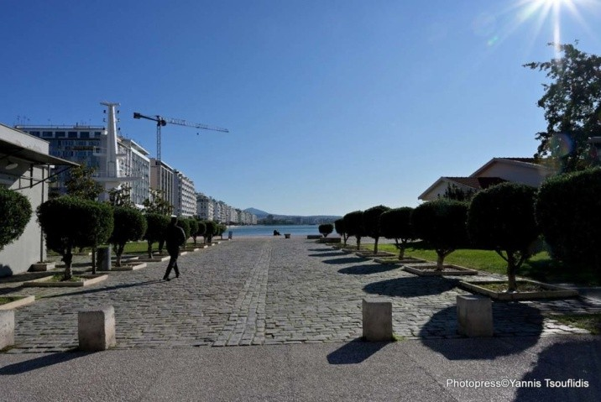
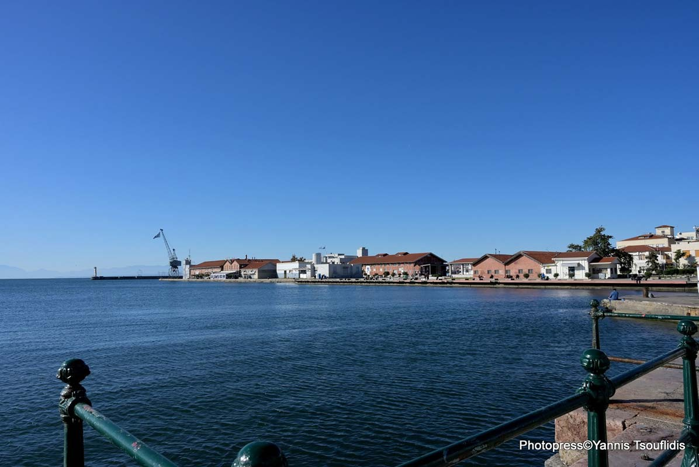

Housing Information & Living Costs

In Thessaloniki you can find many Real Estate businesses that can help you find the apartment you want.

This is a list including the prices of some basic goods that determines the cost of living¨:

Item | Price in Euro
Bus ticket | 0,60 €  0,30 € if you obtain the Academic ID Card
Bottle of water (0,5lt) | 0,50 €
Milk (1 lt) | 1,00-1,80 €
Refreshments | 1,00-2,00 €
Coffee (espresso at a cafeteria) | 2,50-3,50 €
Beer (at a bar) | 4,00-6,00 €
Cinema ticket | 7,50 €
Loaf of Fresh White Bread | 0,90 €
Taxi Start (Normal Tariff) | 3,50 €
Meal (mid-range restaurant) | 15,00 €
Apples (1kg) | 0,80-1,40 €

Visa Information

Applicants from countries outside the Schengen zone need a student visa. Applicants should communicate with the Greek Embassy/Consulate in their country for information on the procedure and also on the time needed for the conclusion of the process.

No visa is required to enter Greece for studies if you possess a valid passport from Iceland, Liechtenstein, Norway or Switzerland.

