

Επισπεύδον Τμήμα
Γεωπονίας
σε συνεργασία με Τμήμα Χημείας

Διατμηματικό Ξενόγλωσσο
Προπτυχιακό Πρόγραμμα Σπουδών
«Sustainable Agriculture and Food Science»

δ.
Κανονισμός λειτουργίας μηχανισμού διαχείρισης παραπόνων και ενστάσεων φοιτητών

Φεβρουάριος / 2026

Το διατμηματικό Ξενόγλωσσο Προπτυχιακό Πρόγραμμα Σπουδών εφαρμόζει τον «Κανονισμό Λειτουργίας Μηχανισμού Διαχείρισης Παραπόνων και Ενστάσεων Φοιτητών/Υποψήφιων Διδακτόρων του Α.Π.Θ.», ο οποίος συμπεριλαμβάνεται στον Εσωτερικό Κανονισμό Λειτουργίας του Α.Π.Θ., όπως εγκρίθηκε με την Απόφαση 3159/14.04.2025 της Συγκλήτου ΑΠΘ και δημοσιεύτηκε στο ΦΕΚ 5130Β/26.09.2025.
Ακολούθως παρατίθεται αυτούσιο το εν λόγω Παράρτημα:
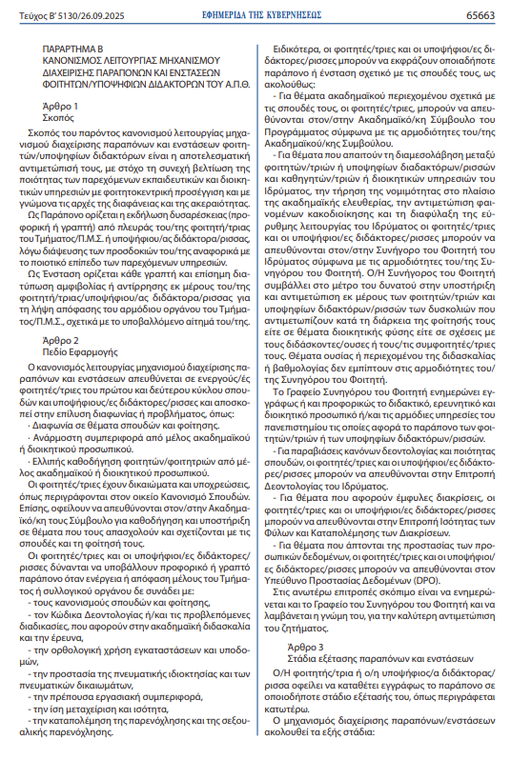
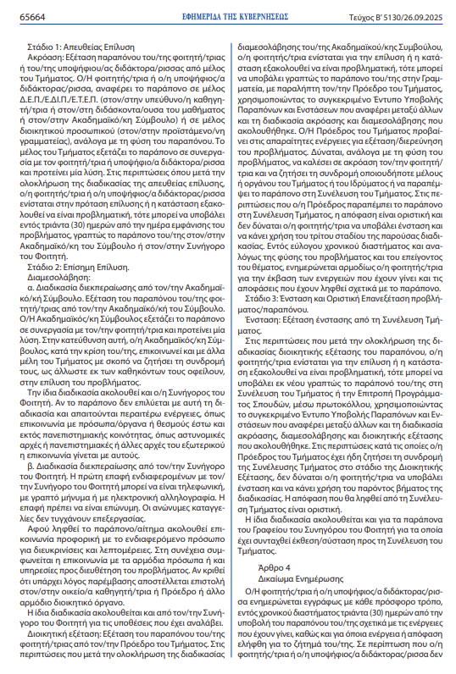

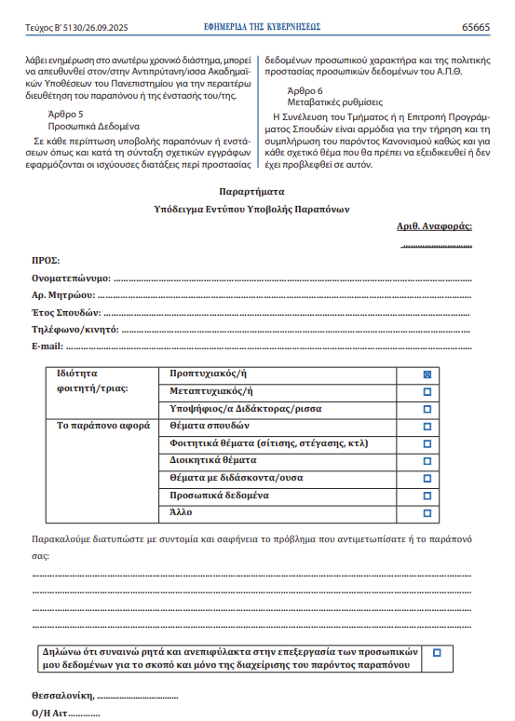

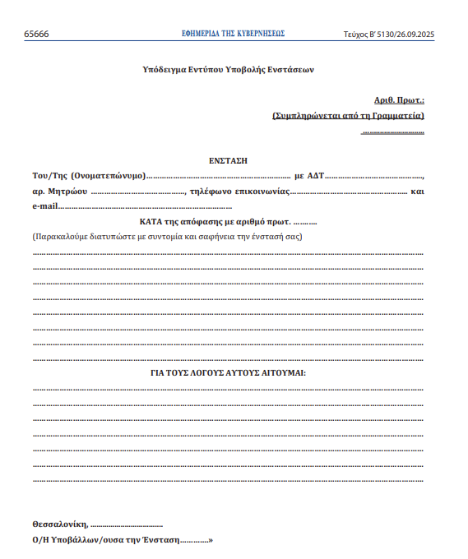

δ.
Κανονισμός λειτουργίας μηχανισμού διαχείρισης παραπόνων και ενστάσεων φοιτητών (eng)

REGULATION FOR THE OPERATION OF THE
COMPLAINTS AND APPEALS MECHANISM
FOR STUDENTS/DOCTORAL CANDIDATES OF THE A.U.TH.
No. 3159/15-4-2025
Meeting of the Senate of the Aristotle University of Thessaloniki

Article 1
Purpose
The purpose of these Regulation governing the mechanism for handling complaints and appeals submitted by students and doctoral candidates is to ensure their effective management, with a view to the continuous improvement of the quality of educational and administrative services provided, adopting a student-centred approach and guided by the principles of transparency and integrity.
A complaint is defined as an expression of dissatisfaction (verbal or written) by a student of the School/Postgraduate Programme or a doctoral candidate, arising from unmet expectations regarding the quality of the services provided.
An appeal is defined as any written and formal expression of doubt or disagreement by a student or doctoral candidate concerning a decision taken by the competent body of the School/Postgraduate Programme in relation to a submitted request.

Article 2
Scope
The Regulation governing the operation of the complaints and appeals mechanism apply to active students of the first and second cycles of study, as well as doctoral candidates, and aim to resolve disputes or issues such as:
- Disagreements concerning matters of study and attendance.
- Inappropriate behaviour by a member of academic or administrative staff.
- Inadequate guidance provided to students by a member of academic or administrative staff.
Students have both rights and obligations, as described in the relevant Study Regulation. They are also encouraged to contact their Academic Advisor for guidance and support on matters related to their studies and attendance.
Students and doctoral candidates may submit verbal or written complaints when an act or decision by a member of the School or a collective body is not in accordance with:
- the study and attendance Regulation,
- the Code of Conduct and/or the procedures governing academic teaching and research,
- the rational use of facilities and infrastructure,
- the protection of intellectual property and copyright,
- appropriate professional conduct,
- equal treatment and equality,
- the prevention of harassment and sexual harassment.
In particular, students and doctoral candidates may raise complaints or objections relating to their studies as follows:
- For academic matters related to their studies, students may contact the Academic Advisor of the Programme, in accordance with the responsibilities of the Academic Advisor.
- For issues requiring mediation between students or doctoral candidates and teaching or administrative staff of the Institution, compliance with the law within the framework of academic freedom, addressing maladministration, and safeguarding the smooth operation of the Institution, students and doctoral candidates may contact the Student Ombudsman, in accordance with the responsibilities of the Student Ombudsman. The Student Ombudsman contributes, as far as possible, to supporting and addressing difficulties encountered by students and doctoral candidates during their studies, whether administrative in nature or related to their relationships with teaching staff or fellow students. Issues relating to the substance or content of teaching or assessment do not fall within the remit of the Student Ombudsman.
The Student Ombudsman’s Office informs the relevant teaching, research and administrative staff and/or the appropriate University Schools concerned by the complaint, either in writing or verbally.
- For violations of rules of conduct and quality of studies, students and doctoral candidates may contact the Ethics Committee of the Institution.
- For issues related to gender discrimination, students and doctoral candidates may contact the Gender Equality and Anti-Discrimination Committee.
- For issues related to personal data protection, students and doctoral candidates may contact the Data Protection Officer (DPO).
It is advisable to inform the Office of the Student Ombudsman and seek its opinion when approaching the above committees, in order to address the issue in the most appropriate manner.

Article 3
Stages of Examination of Complaints and Appeals
The student or doctoral candidate must submit the complaint in writing at any stage of the process described below.
The complaints and appeals management mechanism consists of the following stages:
Stage 1: Direct Resolution
Hearing:
Examination of the complaint submitted by the student or doctoral candidate by a member of the School.
The student or doctoral candidate reports the complaint to a member of the teaching staff (the course instructor, professor in charge, or Academic Advisor) or to a member of the administrative staff (Head of the Secretariat), depending on the nature of the complaint. The member of the School examines the complaint in collaboration with the student or doctoral candidate and proposes a solution.
If, following the completion of the direct resolution process, the student or doctoral candidate disagrees with the proposed solution or the issue remains unresolved, they may submit the complaint in writing to their Academic Advisor or to the Student Ombudsman within thirty (30) days from the date on which the issue arose.
Stage 2: Formal Resolution
Mediation:
a. Procedure handled by the Academic Advisor. The Academic Advisor examines the complaint in collaboration with the student and proposes a solution. For this purpose, the Academic Advisor may, at their discretion, contact other members of the School in order to request their assistance in resolving the issue.
The same procedure applies when the complaint is handled by the Student Ombudsman. If the complaint is not resolved and further action is required, such as communication with bodies outside the University community (e.g. police authorities or foreign academic institutions), the necessary contact is undertaken.
b. Procedure handled by the Student Ombudsman. The initial contact between the interested parties and the Student Ombudsman may be made by telephone, text message or email. The complaint must be submitted with identification; anonymous complaints are not examined. Following receipt of the complaint, verbal communication with the person concerned takes place in order to clarify details. Subsequently, communication with the relevant individuals or services is agreed upon in order to resolve the issue. Where intervention is deemed necessary, a letter is sent to the relevant member of staff or competent administrative body.
Administrative Review: Review of the complaint by the Head of the School.
If, following mediation by the Academic Advisor, the student objects to the outcome or the issue remains unresolved, they may submit the complaint in writing to the Secretariat, addressed to the Head of the School, using the designated Complaints and Appeals Submission Form. The form must include reference to the hearing and mediation stages that have taken place.
The Head of the School undertakes the necessary actions to examine and investigate the matter. Depending on the nature of the issue, the Head may invite the student to a hearing, seek the assistance of any member or body of the School or the Institution, or refer the matter to the School Assembly.
If the complaint is referred to the School Assembly at this stage, the decision of the Assembly is final and the student may not proceed to Stage 3.
Within a reasonable period of time, depending on the nature and urgency of the issue, the student is informed of the outcome and the decisions taken.
Stage 3: Appeal and Final Review

Appeal: Examination of the appeal by the School Assembly.
If, following the administrative review, the student disagrees with the outcome or the issue remains unresolved, they may resubmit the complaint in writing to the School Assembly or the Curriculum Committee, via protocol, using the designated Complaints and Appeals Submission Form, which must refer to the hearing, mediation and administrative review stages.
Where the Head of the School has already referred the matter to the School Assembly during Stage 2, the student may not submit an appeal under this stage.
The decision of the School Assembly is final.
The same procedure applies to complaints submitted to the Office of the Student Ombudsman for which a report or recommendation has been submitted to the School Assembly.

Article 4
Right to Information
The student or doctoral candidate shall be informed in writing, by any appropriate means, within thirty (30) days of submitting the complaint, of the actions taken and any decisions reached.
If no response is received within this time-frame, the student or doctoral candidate may contact the Vice-Rector for Academic Affairs of the University for further handling of the complaint or appeal.
Article 5
Personal Data
In all cases of complaints or appeals, and in the preparation of related documentation, the applicable provisions on personal data protection and the Personal Data Protection Policy of the Aristotle University of Thessaloniki shall apply.

Article 6
Transitional Provisions
The School Assembly or the Curriculum Committee shall be responsible for ensuring compliance with and the proper implementation of these Regulation, as well as for addressing any related matters not explicitly provided for herein.
Appendix
Sample Complaint Submission Form

Reference No: .................
TO
Full Name: ………………………….…………………………………...……………
Registration No.: …………………………………………………………...…………
Year of Study: …………………………………………………………………………
Telephone/Mobile: ……………………………………………………………………
E-mail: …………………………………………………………………………………
Student status: | Undergraduate | ☐
 | Postgraduate | ☐
 | Doctoral candidate | ☐
The complaint concerns: | Study issues | ☐
 | Student issues (catering, accommodation, etc.) | ☐
 | Administrative issues | ☐
 | Issues with teaching staff | ☐
 | Personal data | ☐
 | Other | ☐

Please briefly and clearly describe the issue encountered or your complaint:
…………………………………………………………………………………………………………………………….………………………………………………………
I expressly and unreservedly consent to the processing of my personal data solely for the purpose of handling this complaint. | ☐

Thessaloniki, ....................................
Mr/Ms ………………………

